Task 1. Imagine that you are preparing a project with your friend. You have found some interesting material for the presentation and you want to read this text to your friend. You have 1.5 minutes to read the text silently, then be ready to read it out aloud. You will not have more than 1.5 minutes to read it.

Habits play a fundamental role in shaping our lives. They can be categorized into two distinct types: good habits that enrich our well-being and bad habits that hinder personal growth.
Good habits, such as regular exercise, healthy eating, and time management, contribute positively to physical and mental health. They provide structure, boost productivity, and promote a sense of accomplishment. Cultivating good habits often leads to success and happiness.
On the other hand, bad habits like overindulgence and smoking can be detrimental. They lead to stress, health issues, and hinder progress towards goals. Breaking free from bad habits requires self-awareness and determination.
Developing good habits and eliminating bad ones is an ongoing process. It involves setting clear goals, tracking progress, and seeking support when necessary. The power to change and choose lies within each individual. Embracing good habits and breaking free from bad ones is a powerful tool for personal growth and a fulfilling life.
Task 2. Study the advertisement.
Make your life easier with our new kitchen unit
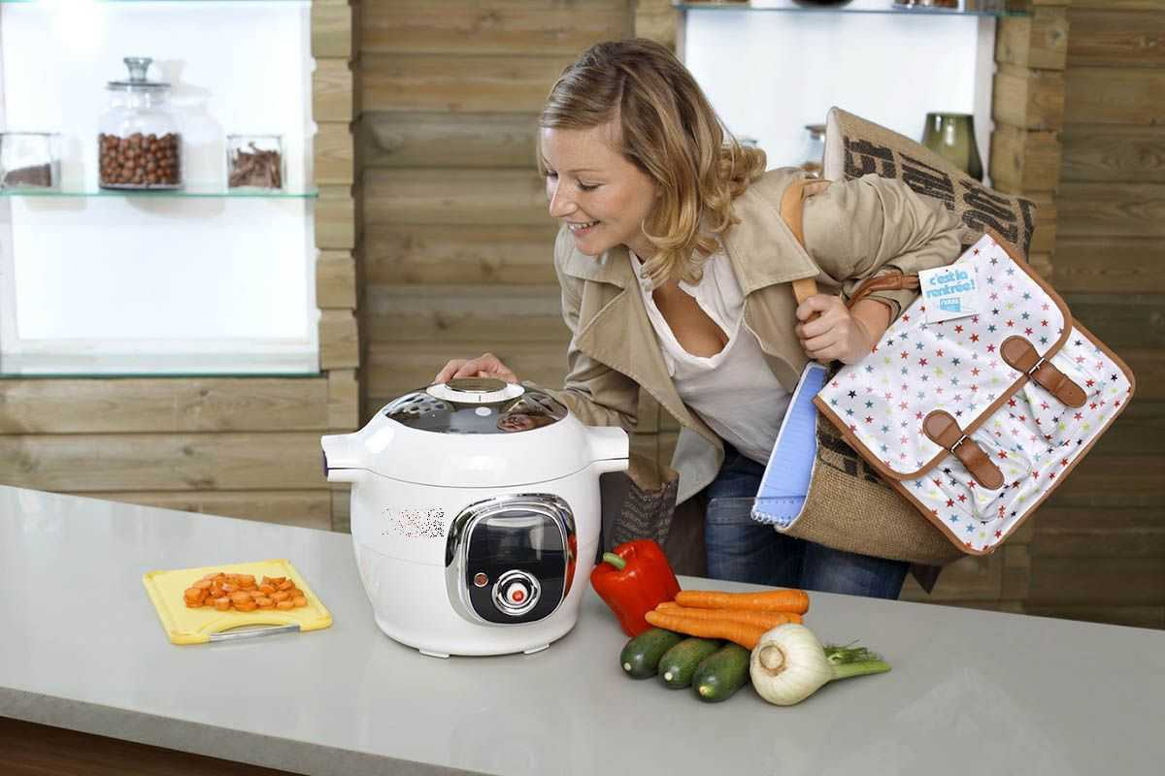

You are considering buying the appliance and now you’d like to get more information. In 1.5 minutes you are to ask four direct questions to find out about the following:

- price
- if one can buy it online
- guarantee period
- recipe book to go with the unit
You have 20 seconds to ask each question
Task 3. You are going to give an interview. You have to answer five questions. Give full answers to the questions (2-3 sentences). Remember that you have 40 seconds to answer each question.

Task 4. Imagine that you are doing a school project “Eating habits” together with your friend. You have found some photos to illustrate it but for technical reasons you cannot send them now. Leave a voice message to your friend explaining your choice of the photos and sharing some ideas about the project. In 2.5 minutes be ready to:
- explain the choice of the illustrations for the project by briefly describing them and noting the differences;
- mention the advantages (1-2) of the two kinds of food;
- mention the disadvantages (1-2) of the two ways of kinds of food;
- express your opinion on the subject of the project – which of the kinds of food presented in the pictures you would prefer and why.

You will speak for not more than 3 minutes (2-3 sentences for each item of the plan, 12–15 sentences total). You have to talk continuously.
Photo 1
Photo 2

